AutoEmail Trigger Changes Tests
Tester: Tony Tasker
Date: 3rd November 2016
Time: 15:00
PC/Server: TonyTasker-PC
Database: CABS_TEST (Copy of SHU DB)
Works Summary: N/A
Works Order: N/A
Task: N/A
Notes: Code as been removed from triggers trAutoEmail_Extras on AI_FILE and trAutoEmail_Booking on FUNC_FIL which could have produced inconsistent results:

SET @SentStatus = isnull((SELECT TOP 1 AEFL_Sent FROM AEF_Link WHERE AEFL_FREF = @BookingNumber),0)

This code does not take into account email type and the subsequent processing could therefore be erroneous.
Pre-Test Setup
No | Task | Tester | Pass | Notes
1 | In X CABS Config, Section AEFCON,  Set  ClassConstraint1=0  Enabled=I:1;U:0;D:0;  In X CABS Config, Section AEFUPD,  Set  ClassConstraint1=0  Enabled=I:0;U:1;D:0;  In X CABS Config, Section CABS_AUTO_EMAIL_FUNCS if WIPWindow is set then  WIPWindow=0 and  DebugFlag=1  In section CABS_AUTO_EMAIL_FUNCS_Trigger  Set DebugFlag=1 | TT

Post-Test Setup
No | Task | Tester | Pass | Notes
1 | Reverse any Config Changes in X CABS Config | TT

Tests

Create a New Function Booking – Confirmation Email – No Update Email
No | Test | Tester | Pass | Notes
1 | Created a new Function in CABS | TT |  | F119342  If frequency is  Frequency=D:0;H:0;M:3;W:1;L:CR;  Then there will be a 3 minute delay before email sent
2 | Run stored procedure  EXEC CABS_AUTO_EMAIL_FUNCS_SESS_CHECK  A Confirmation Email sent but no Update Email | TT |  | See results in figure below.

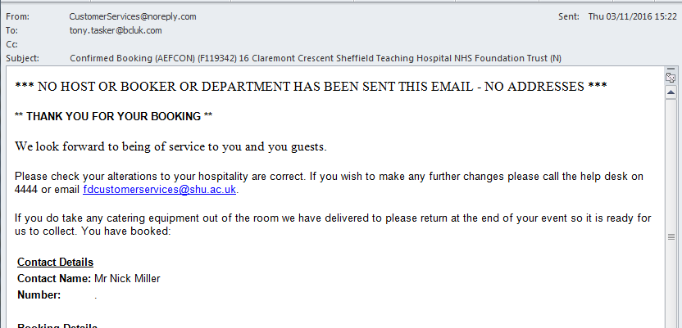
Figure 1 – Confirmation Email

Amend Function Booking – Update Email – No Confirmation EMail
No | Test | Tester | Pass | Notes
1 | Amend Function F119342 in CABS | TT |  | Changed end time from 13:00 to 13:30
2 | Run stored procedure  EXEC CABS_AUTO_EMAIL_FUNCS_SESS_CHECK  No Confirmation Email sent but an Update Email is | TT |  | See results in figures below.

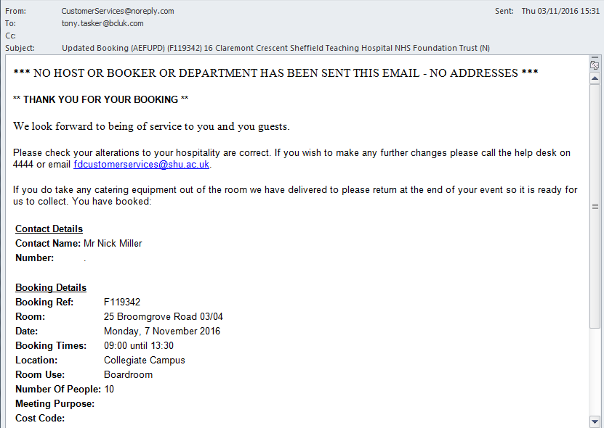
Figure 2 – Update Email

